SmartArt
You can make your document look more appealing by adding graphics to it. Use SmartArt to enrich your document with designer-quality illustrations. SmartArt gives you a number of graphic layouts to choose from. You can add text to the graphics and customize them by changing their style, color and size.

Create a SmartArt graphic and add text to it
- On the Insert tab, in the Illustrations group, click SmartArt.

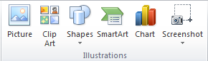

- In the Choose a SmartArt Graphic dialog box click the type of graphic layout that you want.
- Enter your text by doing the following:
- Click [Text] on the graphic shape and then type your text.
- Click [Text] in the Text pane dialog box and then type your text.

NOTES: If you cannot see the Text pane dialog box, under SmartArt Tools, on the Design tab, in the Crate Graphic group, click Text Pane.

Add or delete shapes in your SmartArt graphic
- Click a SmartArt graphic you want to add another shape to.
- Click the existing shape in your SmartArt graphic closest to where you want to add the new shape.
- Under SmartArt Tools, on the Design tab, in the Create Graphic group, click the arrow next to the Add Shape button, and then do one of the following:

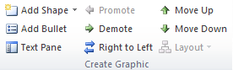

- Click Add Shape After to add a shape after the existing shape.
- Click Add Shape Before to add a shape before the existing shape.

To delete a shape from your SmartArt graphic, click the shape you want to delete, and then press DELETE. To delete your entire SmartArt graphic, click the border of your SmartArt graphic, and then press DELETE.

Change the color of your SmartArt graphic
- Click a SmartArt graphic to select it.
- Under SmartArt Tools, on the Design tab, in the SmartArt Styles group, click Change Colors and pick a color option that you want.

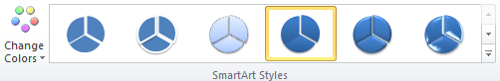

Apply a SmartArt Style to your SmartArt graphic.
With a SmartArt Style you can give different visual effects to the shapes of your SmartArt graphic.
- Click your SmartArt graphic to select it.
- Under SmartArt Tools, on the Design tab, in the SmartArt Styles group, click the style option you want to apply to your SmartArt graphic.
Tip:
- To change the size of your SmartArt graphic, click the border of your SmartArt graphic, and then drag the sizing handles until your SmartArt graphic is the size you want.

